

COURSE NAME: Algorithm Analysis

STUDENT: Ertuğrul ŞENTÜRK

HOMEWORK SUBJECT: Book Recommendation Application

Algorithm:

1. Input file read and stored into the file.
2. The number of similar users to be used in calculation has been received from the user.
3. Pearson's coefficient was calculated with the u members of each nu member with the given inputs.
4. The maximum number of elements as many as the desired number of similar users was moved to the beginning of the array and their indexes were saved in an array named k_max.
5. Information about the similarity rate of these users was printed.
6. Afterwards, the information about whether to suggest for a single user or for all users was received from the user.
7. According to the information received, predictions were made by calling predicate function about the books that were not read by the users.
8. Since the maximum of the predicted books will be the recommended book for the user, the information of that book is printed.

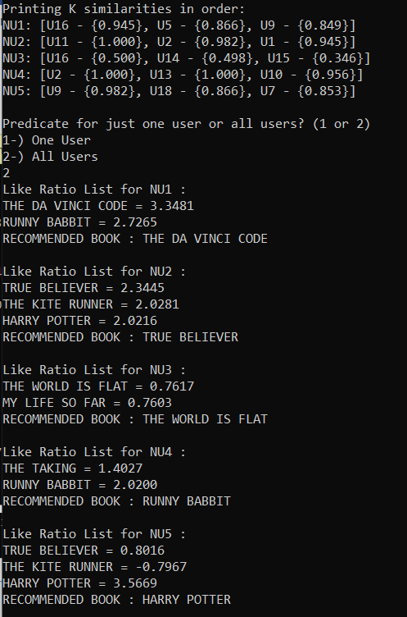Screenshots:

